|  |  |
| --- | --- |
| **Topic**: Reuse and Recycling of Waste Electrical and Electronic Equipment | **Resources:**  **All resources contained within WEEE reuse pack. Request pack from Dave Keith, Recycling Officer, Aberdeen City Council, Tel: 01224 489352, Email:** [**Dkeith@aberdeencity.gov.uk**](mailto:Dkeith@aberdeencity.gov.uk)  **Discussion**   * **Poster 1: Components of a mobile phone** * **Poster 2: Elements of a mobile phone** * **Worksheet 1: Drawing a mobile phone.** * **Poster: Critical Raw Materials** * **Teacher Answer sheet & Pupil worksheet: Number of kilometres travelled by tin.**   **Main Activity:**   * **Old phones for dismantling** * **Tool kits (available from ACC Recycling Team)** * **Worksheet identifying key components** |
| **Topic Overview**: Reuse of electrical and electronic equipment to extend product lifespan and protect scarce resources. |
| **Activity Overview**:  Pupils dismantle a mobile phone to identify the different components and materials used within technology. |
| **Core Experiences & Outcomes**  **TCH 2-02a –** Having analysed how lifestyle can impact on the environment and Earth’s resources, I can make suggestions about how to live in a more sustainable way.  **Learning Intention:** I will understand why reuse is more environmentally friendly than recycling. |
| **Success Criteria:**  I can explain why reuse is preferable to recycling, referring to the valuable materials used in electrical and electronic equipment. |
| **Science Skills**  Observing, Experimenting, Recording, | |
| **Key Vocabulary:**  **WEEE** – Waste Electrical and Electronic Equipment. Electrical and Electronic items are defined as items with a plug or battery.  **Waste Hierarchy** Diagram illustrates the Scottish Government definition.  For children it is usually shortened to the 3 R’s (Reduce, Reuse, Recycle).  **Reduce –** lowering how much energy and/or materials are used e.g. purchasing items with no/ less packaging.  **Reuse –** using items again (and again) for example by donating or purchasing items from a charity shop.  **Recycle –** convert waste into reusable material  **Circular Economy**: A move from the conventional “make goods – use goods – dispose of goods” approach. The circular economy is an alternative system in which products and materials are kept in a high-value state of use for as long as possible. For example designing a phone to be easily repaired, rather than replaced.  **Critical Raw Materials** – Critical raw materials (CRMs) are not necessarily materials that are scarce. A material is defined as a CRM if it meets the following three criteria:   * Economically important for key sectors in the European economy, such as consumer electronics, automotive, aerospace, etc. * A fragile supply chain e.g. the material is typically imported from particular countries. * There is a lack of (viable) substitutes, due to the very unique and reliable properties of these materials. | |
| **Teacher Links**  For information on the waste hierarchy (Eco-schools):  <http://www.keepscotlandbeautiful.org/sustainable-development-education/eco-schools/ten-topics/waste-minimisation/>  Video clip describing Circular Economy produced by Ellen MacArthur Foundation (suitable for children):  <https://youtu.be/zCRKvDyyHmI>  Video clip about electronics recycling produced by recycle now (suitable for children): <https://vimeo.com/12730094>  Video clip from Fairphone entitled: Fairphone research trip: Visiting tin, tantalum and tungsten mines Note: This clip is recommended for pupils aged 10 plus due to vocabulary used.  <https://vimeo.com/107812653>  Video clip from BGS describing critical raw materials, their uses and issues concerning their supply. Clip recommended for pupils aged 10 plus, however very informative for teachers wishing to gain background information very quickly.  <http://www.bgs.ac.uk/mineralsuk/statistics/criticalRawMaterials.html>  BGS weblink with several short animations suitable for children of all ages and mixed abilities showing how many minerals are used by an average person.  <http://www.bgs.ac.uk/mineralsuk/mineralsYou/howUse.html> | |
| **Topic Plan** | |
| This topic has been broken down into 30 minute – 1 hour sessions to enable teachers to either work through the topic over the course of a term, or to pick and choose sessions based on the interests of pupils. Workshops and a resource pack to support learning can be arranged through the Aberdeen City Council’s Recycling Team. | |
| **Establishing Prior Knowledge (10 mins):**  **Discussion Points**   * Discussion of waste hierarchy (Reduce, Reuse, Recycle). * What is electrical/ electronic equipment? (Anything with a plug) | |
| **Concept Introduction (20 mins):**  **“Hands-up” survey on Ownership of Electrical/ Electronic Items**   * How many mobile phones are there in your home? * Count up how many phones are present within homes within the class.   Pupils could suggest additional electrical items that they own. Pupils to get an appreciation of how many electrical items have been manufactured in the world.  **Fun Facts to support discussion**:   * There will be 65m smartphones in UK in 2017. That’s equal to one per person. (Source: WRAP). * 300,000 smartphones are currently hoarded in homes & offices. (Source: WRAP). * On average, each person in the UK buys almost three new electrical items each year – or around 170 million nationally (Source: Recycle now). * For every 5.9kg of small electricals purchased in 2012 (the average mass per person), only a fraction of these items (1.8kg) were sent to be recycled (Source: Recycle now).   **Introductory Activity ( 1hr): What’s inside a tablet/ mobile**  **This activity could be done in conjunction with the main activity (taking apart a mobile phone).**  The powerpoint presentation and Poster 1 and Poster 2 detail the different materials that make up a tablet/ mobile phone. Approximately 40 different elements are used within each phone/ tablet.  Pupils to use Worksheet 1: Outline of mobile phone to draw the different components of a tablet/ mobile.  If your school has requested the resource box, it will contain a tablet that has been broken down to enable pupils to see the different components.  Ask the pupils to think about the different parts of the phone and the time and effort that is required to manufacture a phone.  **Main Activity: Components of Phones/ technology**  **Health and Safety**   1. **Prior to providing the pupils with a phone to take apart remove the battery intact. Batteries contain hazardous materials and should be recycled appropriately.** 2. **Many components or tools will contain sharp edges, which could present a potential risk, care should be taken at the outset to ensure that pupils take responsibility for their actions.** 3. **Containers should be provided for the components to be placed into. At the end of the session, all components should be recycled appropriately.**   **Activity (approximately 45 minutes – 1hr)**   1. Provide pupils with phones that have had the battery removed and a selection of tools. 2. Remove the small screws located on the back cover (some screws may be covered by stickers) if necessary. 3. Separate the battery compartment to expose the circuit board. 4. Remove the small screws securing the circuit board. 5. The vast majority of components are on the circuit board, but there will be others on the casing, etc that can also be removed, e.g. the screen, speaker, etc. 6. There are approximately 300 components within each phone, ask the pupils to separate out the components and to count up and identify individual components and their uses. 7. Ask the pupils to photograph the activity or draw the individual components. 8. Ensure that the components are put into tubs to ensure that they can be recycled appropriately at the end of the session. | |
| **Follow-on Activity: Components of Electrical/ Electronic Equipment**  Discuss that some metals are very important, but that there can be issues with their supply. These are called critical raw materials. These elements are often used in electronic equipment and without them, it would be difficult to manufacture electronic/ electrical goods.  Pupils to suggest electrical/ electronic equipment that they use and how they would feel/ what they would do if they could not use it. E.g. Mobile phones used to call/ text friends and family. Pupils may feel more isolated because they cannot speak to people they care about.  Research “critical raw materials” and watch the Video clip from Fairphone entitled: Fairphone research trip: Visiting tin, tantalum and tungsten mines.  Note: This clip is recommended for pupils aged 10 plus due to vocabulary used.  [**https://vimeo.com/107812653**](https://vimeo.com/107812653)  **Discussion points**   1. Pupils to consider how they would feel working in the mines. 2. Pupils to consider ways that reduce their use of scarce resources e.g.  * Not upgrading as frequently * Buying second hand equipment * Repairing equipment * Taking care of items to ensure that they last longer * Passing on/ selling unwanted items for other people to use. * Raising awareness * Buying sustainably manufactured equipment (if possible).   The teachers’ resource pack contains a map of critical raw materials to identify where in the world they are mined. Pupils to complete worksheet looking at the number of miles travelled by tin within a phone (**Answer: 23,696km, assuming phone is used in Aberdeen**).  **Fun Facts**:   * Mobile phones contain over 40 different chemical elements and hundreds of components. Pupils to think about the number of kilometres/ miles travelled by the elements within a phone. * Mobile phones contain gold, platinum, tin, lead, silver, copper, silver, aluminium and a range of other elements. These elements have to be mined and some are very rare. | |
| **Conclusions**:   * What happens to electronic/ electrical equipment owned by the pupils/ families when it is no longer needed?   Suggested responses may include: Passed on to friends/ family, hoarded, recycled, landfilled/ binned, sold, donated to charity shops.   * Discuss the merits/ disadvantages of what happens to equipment when it is no longer needed. * Briefly introduce the waste hierarchy (reduce, reuse, recycle). | |
| **Extension ideas:**   * Pupils design posters/ leaflets to raise awareness of the importance of reusing equipment. * Pupils research the different elements that are found within a phone. | |
| **Home Links:**   * Pupils to discuss with family what happens to unwanted equipment. | |

**Teachers’ Resources**



**What is inside a mobile phone? (Diagram from Fairphone website)**

Speaker

Earpiece

Buttons

Flexible PCB

Screen

Screen PCB

Battery connector

Printed Circuit Board

Capacitors

Chips

Sim card slot

Component connectors

Vibrating mechanism

**What’s inside a tablet?**

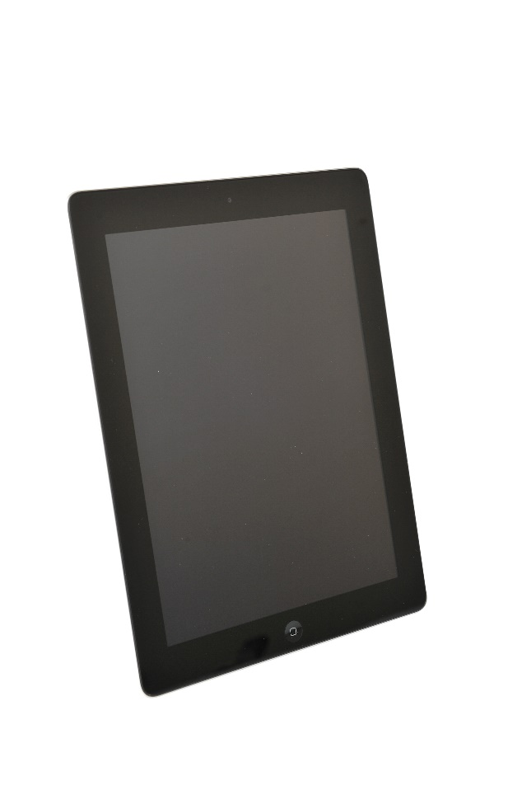

Casing

Plastic or Magnesium Compounds: Used for phone cases.

Battery

Lithium Ion: Typically used for battery

Aluminium: Used for battery casing.

Electronics

Copper: Used for wiring.

Copper, Gold and Silver: Used for the microelectrical components.

Nickel: Used in the microphone.

Silicon: Used in the chip.

Copper, Silver & Tin: Used to connect the components (solder)

Screen

Glass: Usually strengthened to minimise cracking.

Rare Earth Elements: Used to give the screen colour.

Indium Tin Oxide: Enables the screen to act as a touch screen.

**Where do critical raw materials come from?**

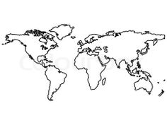

Canada

* Cobalt

USA

* Beryllium

Mexico

* Fluorspar

Rwanda

* Tantalum

South Africa

* Platinum Group metals

Russia

* Platinum Group metals

China

* Antimony
* Beryllium
* Fluorspar
* Gallium
* Graphite
* Germanium
* Indium
* Magnesium
* Rare Earths
* Tungsten

Japan

* Indium

India

* Graphite

Brazil

* Niobium
* Tantalum

Democratic Republic Congo

* Cobalt
* Tantalum

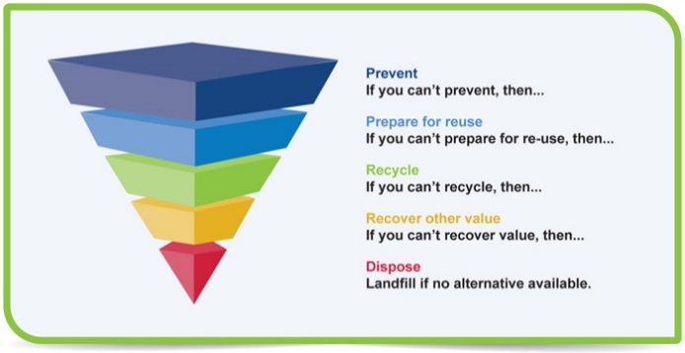**Waste Hierarchy Diagram from Scottish Government**

**Pupil Activity Sheets**

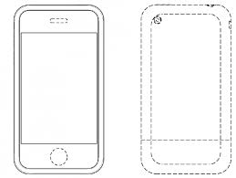Draw the different parts of a mobile phone

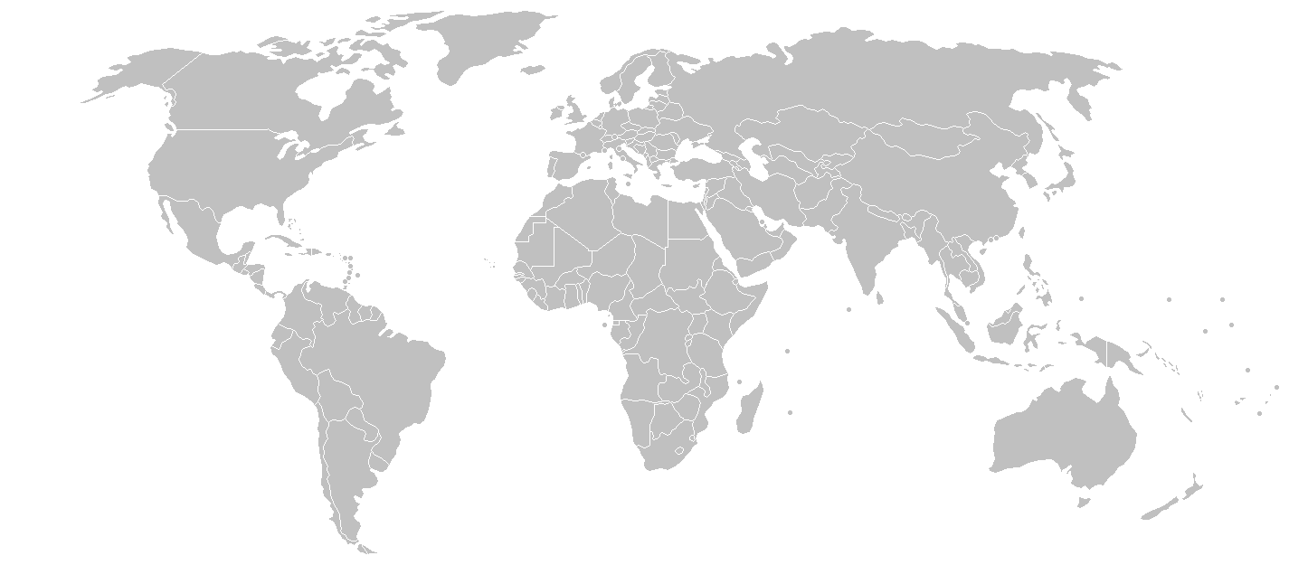Add together the number of kilometres travelled by tin and write your answer in the red box.

1. Can you guess how many days it would take you to walk?

**Km**

**8303 km**

3503 km

2863 km

7017 km

Tanzania

Used: Aberdeen

Tin solder: Bangalore

Smeltered:Malaysia

Manufactured: China

2010 km

Mined in Democratic Republic of Congo