|  |  |
| --- | --- |
| **Topic**: Reuse and Recycling of Waste Electrical and Electronic Equipment | **Resources:**  **All resources contained within WEEE reuse pack. Request pack from Dave Keith, Recycling Officer, Aberdeen City Council, Tel: 01224 489352, Email:** [**Dkeith@aberdeencity.gov.uk**](mailto:Dkeith@aberdeencity.gov.uk)  **Level One/ Introductory Activity:**   * **Poster 1: Components of a mobile phone** * **Poster 2: Elements of a mobile phone** * **A Framed Tablet** * **Worksheet 1: Drawing a mobile phone.**   **Level 2/ Follow-on Activity:**   * **Poster: Critical Raw Materials** * **Teacher Answer sheet & Pupil worksheet: Number of kilometres travelled by tin.**   **Main Activity:**   * **Lego Phones with spare Lego bricks.** * **Electrical Equipment for testing** * **Levels 1 & 2 Worksheets: Reusing Lego Phones/ Electronic Equipment.** |
| **Topic Overview**: Reuse of electrical and electronic equipment to extend product lifespan and protect scarce resources. |
| **Activity Overview**:  **Level 1**: Pupils “repair” Lego phones for reuse. Pupils identify the value associated with re-selling equipment and discover the benefits of reuse.  **Level 2**: Pupils “test” equipment for reuse. Pupils identify the value associated with re-selling equipment and discover the benefits of reuse. |
| **Core Experiences & Outcomes**  **TCH 2-02a –** Having analysed how lifestyle can impact on the environment and Earth’s resources, I can make suggestions about how to live in a more sustainable way.  **Learning Intention:** I will understand why reuse is more environmentally friendly than recycling. |
| **Success Criteria:**  I can explain why reuse is preferable to recycling, referring to the valuable materials used in electrical and electronic equipment. |
| **Science Skills**  Observing, Experimenting, Recording, | |
| **Key Vocabulary:**  **WEEE** – Waste Electrical and Electronic Equipment. Electrical and Electronic items are defined as items with a plug or battery.  **Waste Hierarchy** Diagram illustrates the Scottish Government definition.  For children it is usually shortened to the 3 R’s (Reduce, Reuse, Recycle).  **Reduce –** lowering how much energy and/or materials are used e.g. purchasing items with no/ less packaging.  **Reuse –** using items again (and again) for example by donating or purchasing items from a charity shop.  **Recycle –** convert waste into reusable material  **Circular Economy**: A move from the conventional “make goods – use goods – dispose of goods” approach. The circular economy is an alternative system in which products and materials are kept in a high-value state of use for as long as possible. For example designing a phone to be easily repaired, rather than replaced. | |
| **Teacher Links**  For information on the waste hierarchy (Eco-schools):  <http://www.keepscotlandbeautiful.org/sustainable-development-education/eco-schools/ten-topics/waste-minimisation/>  Video clip describing Circular Economy produced by Ellen MacArthur Foundation (suitable for children):  <https://youtu.be/zCRKvDyyHmI>  Video clip about electronics recycling produced by recycle now (suitable for children): <https://vimeo.com/12730094>  Video clip from Fairphone entitled: Fairphone research trip: Visiting tin, tantalum and tungsten mines Note: This clip is recommended for pupils aged 10 plus due to vocabulary used.  <https://www.fairphone.com/resources/>  Video clip from BGS describing critical raw materials, their uses and issues concerning their supply. Clip recommended for pupils aged 10 plus, however very informative for teachers wishing to gain background information very quickly.  <http://www.bgs.ac.uk/mineralsuk/statistics/criticalRawMaterials.html>  BGS weblink with several short animations suitable for children of all ages and mixed abilities showing how many minerals are used by an average person.  <http://www.bgs.ac.uk/mineralsuk/mineralsYou/howUse.html> | |
| **Topic Plan** | |
| This topic has been broken down into 30 minute – 1 hour sessions to enable teachers to either work through the topic over the course of a term, or to pick and choose sessions based on the interests of pupils. Workshops and a resource pack to support learning can be arranged through the Aberdeen City Council’s Recycling Team. | |
| **Establishing Prior Knowledge (10 mins):**  **Discussion Points**   * Discussion of waste hierarchy (Reduce, Reuse, Recycle). * What is electrical/ electronic equipment? | |
| **Concept Introduction (30 mins):**  **“Hands-up” survey on Ownership of Electrical/ Electronic Items**   * How many mobile phones are there in your home? * How many laptops/ computers are there in your home? * How many printers are there in your home?   Pupils could suggest additional electrical items that they own. Pupils to get an appreciation of how many electrical items have been manufactured in the world.  **Fun Facts to support discussion**:   * There will be 65m smartphones in UK in 2017. That’s equal to one per person. (Source: WRAP). * 300,000 smartphones are currently hoarded in homes & offices. (Source: WRAP). * On average, each person in the UK buys almost three new electrical items each year – or around 170 million nationally (Source: Recycle now). * For every 5.9kg of small electricals purchased in 2012 (the average mass per person), only a fraction of these items (1.8kg) were sent to be recycled (Source: Recycle now).   **Level 1/ Introductory Activity ( 1hr): What’s inside a tablet**  The powerpoint presentation and Poster 1 and Poster 2 detail the different materials that make up a tablet/ mobile phone. Approximately 40 different elements are used within each phone/ tablet.  Pupils to use Worksheet 1: Outline of mobile phone to draw the different components of a tablet/ mobile.  If your school has requested the resource box, it will contain a tablet that has been broken down to enable pupils to see the different components.  Ask the pupils to think about the different parts of the phone and the time and effort that is required to manufacture a phone.  **Follow-on Activity: Components of Electrical/ Electronic Equipment**  Discuss that some metals are very important, but that there can be issues with their supply. These are called critical raw materials. These elements are often used in electronic equipment and without them, it would be difficult to manufacture electronic/ electrical goods.  Pupils to suggest electrical/ electronic equipment that they use and how they would feel/ what they would do if they could not use it. E.g. Mobile phones used to call/ text friends and family. Pupils may feel more isolated because they cannot speak to people they care about.  The teachers’ resource pack contains a map of critical raw materials to identify where in the world they are mined. Pupils to complete worksheet looking at the number of miles travelled by tin within a phone (**Answer: 23,696km, assuming phone is used in Aberdeen**).  **Fun Facts**:   * Mobile phones contain over 40 different chemical elements and hundreds of components. Pupils to think about the number of kilometres/ miles travelled by the elements within a phone. * Mobile phones contain gold, platinum, tin, lead, silver, copper, silver, aluminium and a range of other elements. These elements have to be mined and some are very rare.   **Discussion**:   * What happens to electronic/ electrical equipment when it is no longer needed?   Suggested responses may include: Passed on to friends/ family, hoarded, recycled, landfilled/ binned, sold, donated to charity shops.   * Discuss the merits/ disadvantages of what happens to equipment when it is no longer needed. * Briefly introduce the waste hierarchy (reduce, reuse, recycle). | |
| **Main Activity:**  **Level 1 Activity: Repairing Lego Phones**   1. Show pupils the Lego phones and explain that some have missing parts but could be fixed. Discuss with pupils what could happen to the “Lego phones” e.g. phones that can be fixed could be reused, phones that could not be fixed could be recycled. 2. Inform the class that phones that could be reused could be sold for £10, and phones that can be recycled could be sold for £5. The aim of the activity is to reuse as many phones as possible. 3. Discuss with pupils the roles and responsibilities required to reuse and recycle the Lego phones and split the class into groups based on different roles. 4. Pupils “fix” mobile phones by re-attaching Lego buttons, screens, etc. 5. Count the number of “Lego phones” that can be reused and recycled. 6. Complete Level 1 Worksheet: Repairing Lego Phones in groups or individually.   **Level 2 Activity: Equipment for Reuse**   1. Show pupils the used electrical equipment and explain that some works and some is broken. Discuss with pupils how the equipment could be reused or recycled. 2. Explain to the class that they are going to “test” the equipment to see if it still works. Items that are functional can be reused for £10, items that are broken can be recycled for £5. The aim of the activity is to reuse as many items as possible. 3. Discuss with the class that the items will need to be switched on to see if they work. (Remind the class to switch off once the item has been tested). 4. Discuss with pupils the roles and responsibilities required to reuse and recycle the equipment and split the class into groups based on different roles. 5. Count the equipment that can be reused/ recycled and complete the Level 2 Worksheet: Equipment for Reuse. | |
| **Follow-on Discussion:**   * Discuss what happens to unwanted equipment within school and at home. | |
| **Extension ideas:**   * Pupils design posters/ leaflets to raise awareness of the importance of reusing equipment. * Pupils produce a bar chart/ pie chart of different types of equipment owned by families/ the school. * Pupils link with Aberdeen City Council’s Waste Team to organise a WEEE reuse collection day (full resources available). | |
| **Home Links:**   * Pupils to discuss with family what happens to unwanted equipment. * Pupils to count the number of electrical and electrical items within the house. | |

**Teachers’ Resources**



**What is inside a mobile phone? (Diagram from Fairphone website)**

Speaker

Earpiece

Buttons

Flexible PCB

Screen

Screen PCB

Battery connector

Printed Circuit Board

Capacitors

Chips

Sim card slot

Component connectors

Vibrating mechanism

**What’s inside a tablet?**

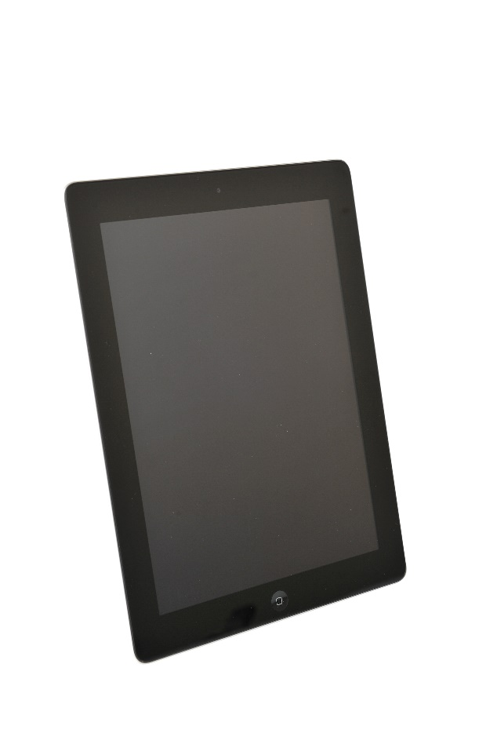

Casing

Plastic or Magnesium Compounds: Used for phone cases.

Battery

Lithium Ion: Typically used for battery

Aluminium: Used for battery casing.

Electronics

Copper: Used for wiring.

Copper, Gold and Silver: Used for the microelectrical components.

Nickel: Used in the microphone.

Silicon: Used in the chip.

Copper, Silver & Tin: Used to connect the components (solder)

Screen

Glass: Usually strengthened to minimise cracking.

Rare Earth Elements: Used to give the screen colour.

Indium Tin Oxide: Enables the screen to act as a touch screen.

**Where do critical raw materials come from?**



Canada

* Cobalt

USA

* Beryllium

Mexico

* Fluorspar

Rwanda

* Tantalum

South Africa

* Platinum Group metals

Russia

* Platinum Group metals

China

* Antimony
* Beryllium
* Fluorspar
* Gallium
* Graphite
* Germanium
* Indium
* Magnesium
* Rare Earths
* Tungsten

Japan

* Indium

India

* Graphite

Brazil

* Niobium
* Tantalum

Democratic Republic Congo

* Cobalt
* Tantalum

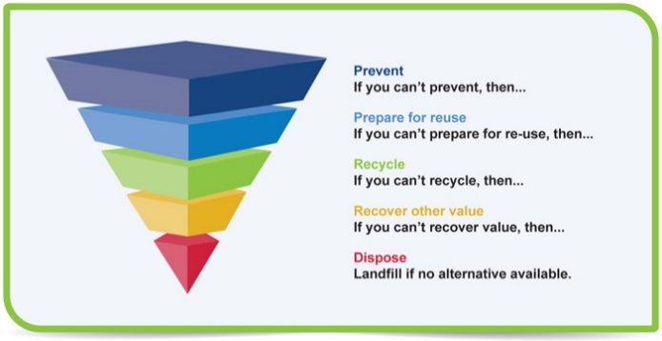**Waste Hierarchy Diagram from Scottish Government**

**Pupil Activity Sheets**

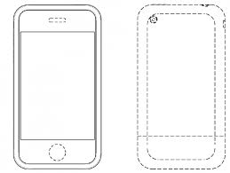Draw the different parts of a mobile phone

Count the number of phones that can be **REUSED**.

|  |  |  |  |  |  |  |
| --- | --- | --- | --- | --- | --- | --- |
|  | | = | | |  | |
| Each phone that can be **REUSED** is worth **£10** | | | | | | |
| **Multiply** the number of phones by £10 to see how much money could be made by reusing phones. | | | | | | |
|  | **X** | | **£10** | **=** | | **£** |
| Number of phones |  | |  |  | |  |
| Count the number of phones that can be **RECYCLED**. | | | | | | |
|  | | = | | |  | |
| Each phone that can be **RECYCLED** is worth **£5** | | | | | | |
| **Multiply** the number of phones that can be **recycled** by **£5** to see how much money could be made by **recycling** phones. | | | | | | |
|  | **X** | | **£5** | **=** | | **£** |
| Number of phones |  | |  |  | |  |

Count the items that can be **REUSED**.

|  |  |  |  |  |  |  |
| --- | --- | --- | --- | --- | --- | --- |
|  | | = | | |  | |
| Each item that can be **REUSED** is worth **£10** | | | | | | |
| **Multiply** the number of items by £10 to see how much money could be made by reusing items. | | | | | | |
|  | **X** | | **£10** | **=** | | **£** |
| Number of items |  | |  |  | |  |
| Count the number of items that can be **RECYCLED**. | | | | | | |
|  | | = | | |  | |
| Each item that can be **RECYCLED** is worth **£5** | | | | | | |
| **Multiply** the number of items that can be **recycled** by **£5** to see how much money could be made by **recycling** equipment. | | | | | | |
|  | **X** | | **£5** | **=** | | **£** |
| Number of items |  | |  |  | |  |

**Calculate the total value of the electrical equipment**

|  |  |  |  |  |
| --- | --- | --- | --- | --- |
| **£** | **+** | **£** | **=** | **£** |
| Total value of reused items |  | Total value of recycled items |  | Profit |

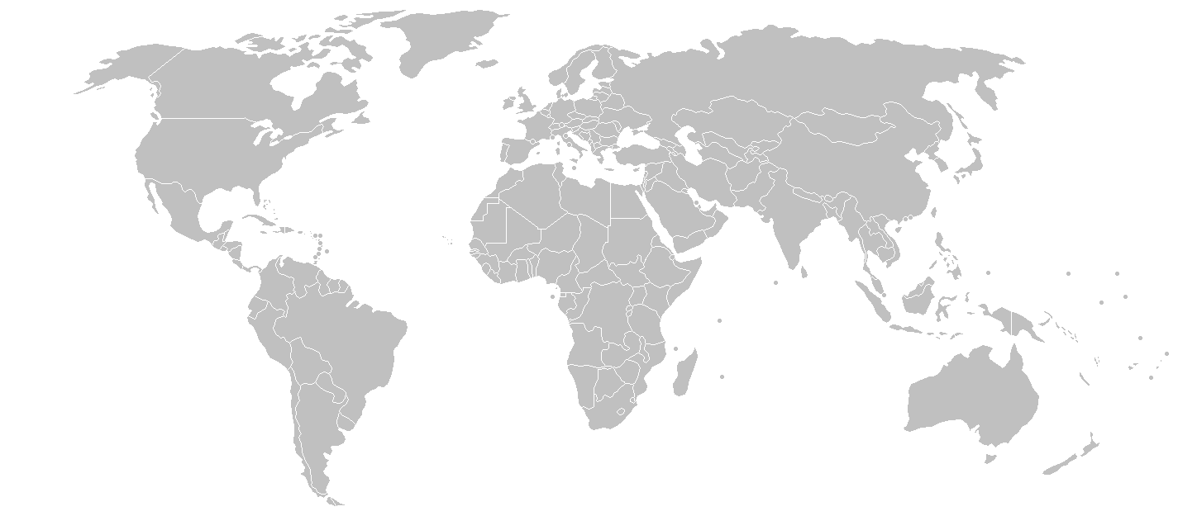Add together the number of kilometres travelled by tin and write your answer in the red box.

1. Can you guess how many days it would take you to walk?

**Km**

**8303 km**

3503 km

2863 km

7017 km

Tanzania

Used: Aberdeen

Tin solder: Bangalore

Smeltered:Malaysia

Manufactured: China

2010 km

Mined in Democratic Republic of Congo